installing ios and backup

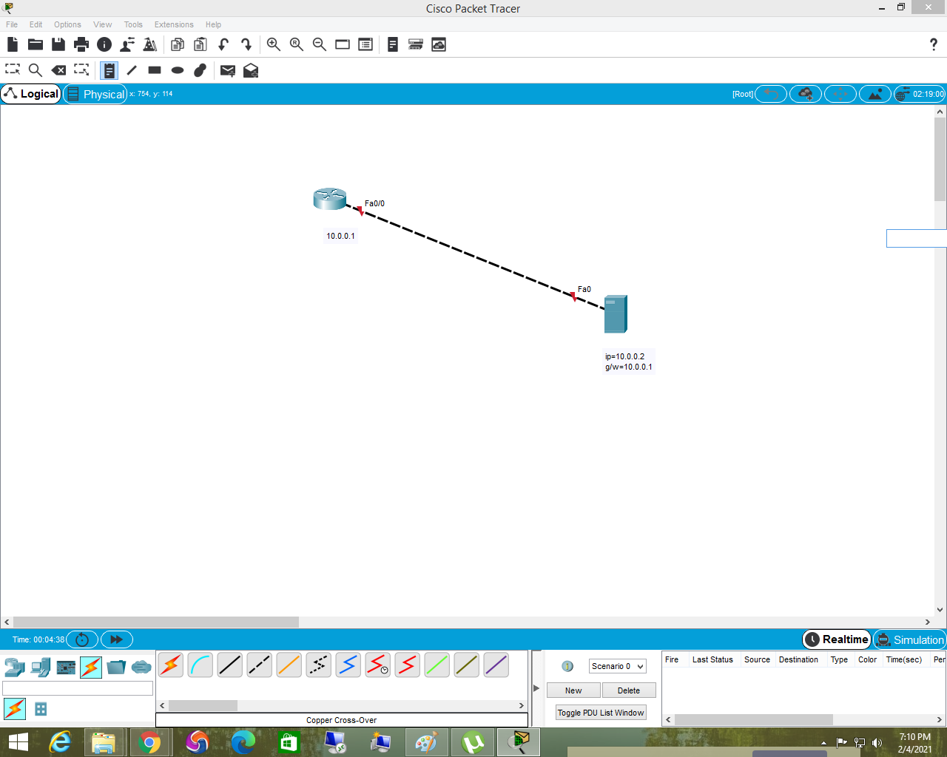

how to delet ios

to check the ios

Router>enable

Router#show flash

System flash directory:

File Length Name/status

3 33591768 c1841-advipservicesk9-mz.124-15.T1.bin

2 28282 sigdef-category.xml

1 227537 sigdef-default.xml

[33847587 bytes used, 30168797 available, 64016384 total]

63488K bytes of processor board System flash (Read/Write)

deleting ios

Router#delet flash:c1841-advipservicesk9-mz.124-15.T1.bin

Router#reload

----------------------------------------------------------------------------

installing ios using tftp server trivial file transfer protocol

tftpserver configuration:

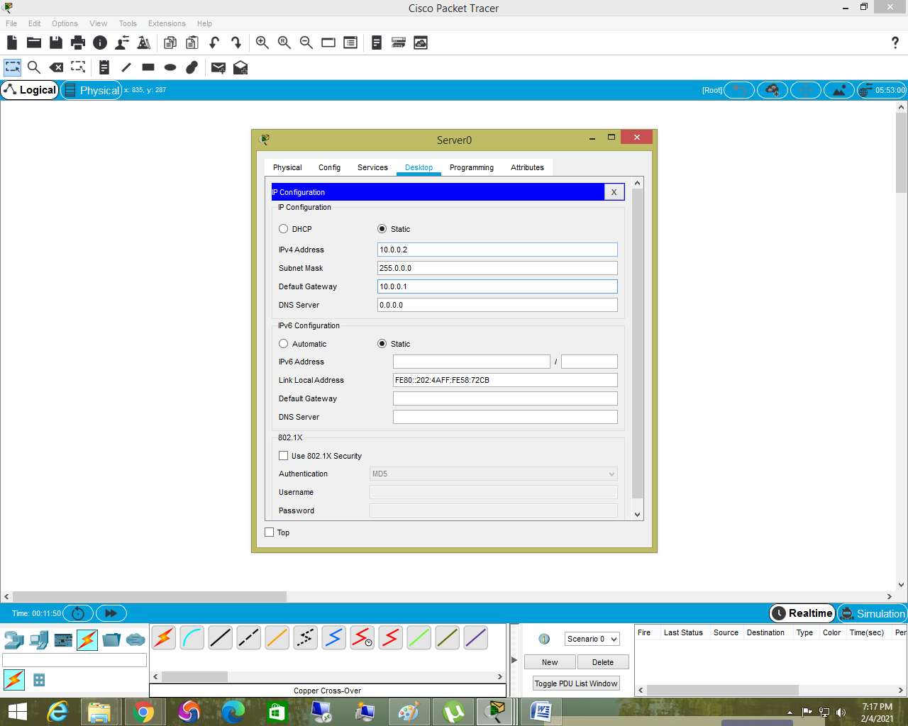

rommon 1> tftpdnld

rommon 2 > IP_ADDRESS=10.0.0.1

rommon 3 > IP_SUBNET_MASK=255.0.0.0

rommon 4 > DEFAULT_GATEWAY=10.0.0.2

rommon 5 > TFTP_SERVER=10.0.0.2

rommon 6 > TFTP_FILE=c1841-ipbase-mz.123-14.T7.bin

rommon 7 > tftpdnld

Do you wish to continue? y/n: [n]: y

rommon 8 > boot

----------------------------------------------------------

upgrading ios

interface ip configuration first

Router>enable

Router#configure terminal

Router(config)#interface fa0/0

Router(config-if)#ip address 10.0.0.1 255.0.0.0

Router(config-if)#no shutdown

Router#copy tftp flash:

Address or name of remote host []? 10.0.0.2

Source filename []? c1841-advipservicesk9-mz.124-15.T1.bin

Destination filename [c1841-advipservicesk9-mz.124-15.T1.bin]?

after installing ios delet old version

to save configuration file

R1#copy running-config startup-config

(or)

R1#write

how to backup startup config file

R1#copy startup-config tftp

Address or name of remote host []? 10.0.0.2

Destination filename [R1-confg]?

how to erase start up config

erase startup-config

how to download saved data from tftp

Router#copy tftp: startup-config

Address or name of remote host []? 10.0.0.2

Source filename []? R1-confg

Destination filename [startup-config]?

Nvram-to Ram data copy

Router#copy startup-config running-config